William Fisher Medical Centre Patient Questionnaire March 2014
Dear Patient,
We hope you will be willing to complete this short survey to help us have a better understanding of our patients and their health needs.
Our Practice Manager and Patient Participation Group will analyse the results and prepare an action plan, to address patient concerns where it is possible to do so.
To make the results more accessible, the survey results and comments, together with the action plan will be published on the practice website as well as being displayed in the surgery.
Please consider joining our Virtual Patient Participation Group. By becoming a member we will communicate with you by email, requesting that you visit our website and complete any future surveys we may undertake from time to time. We will keep our surveys succinct so it shouldn't take too much of your time.
If you are happy for us to contact you occasionally by email, please click the ' Join Our Patient Group' link on our website ' Home’ page to open the signup form and complete all the fields.

2014 Patient Survey
Please answer all of the questions and click 'Send Survey' when you are done.

A. Appointments at your Health Centre

Q1. When did you last see a Doctor at the Health Centre?
In the past 3 months 77%
Between 3 and 6 months ago 15%
More than 6 months ago 5%
I have never been seen at my present Health Centre 1%
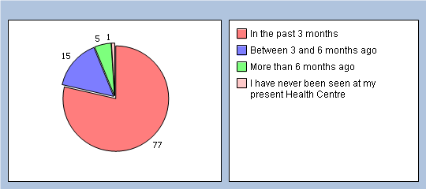

Q2. If you haven't seen a Doctor in the past 6 months, why is that ? Please tick all that apply
I haven't needed to see a Doctor 11%
I couldn't be seen at a convenient time 0%
I couldn't get to my appointment easily 0%
Another reason 2%

B. Getting through on the phone

Q3. In the past 6 months how easy have you found getting through on the phone ?
Haven't tried 8%
Very easy 36%
Fairly easy 44%
Not very easy 6%
Not at all easy 2%
Don’t know 0%
No response 4%
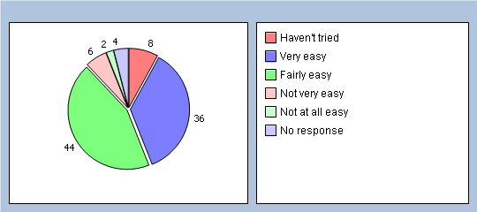

Q4. In the past 6 months how easy have you found getting to speak to a Doctor on the phone ?
Haven't tried 75%
Very easy 8%
Fairly easy 6%
Not very easy 4%
Not at all easy 1%
Don’t know 2%
No response 4%
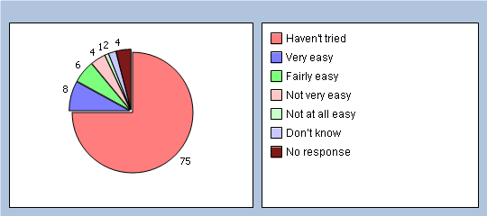

Q5. In the past 6 months how easy have you found getting to speak to a Nurse on the phone ?
Haven't tried 71%
Very easy 9%
Fairly easy 11%
Not very easy 0%
Not at all easy 0%
Don’t know 3%
No response 6%
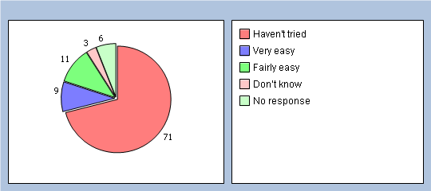

Q6. In the past 6 months how easy have you found obtaining test results on the phone ?
Haven't tried 65%
Very easy 24%
Fairly easy 3%
Not very easy 2%
Not at all easy 0%
Don’t know 1%
No response 5%
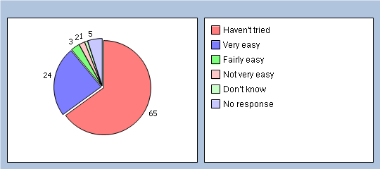

Q7. At present all calls are answered by our receptionists, which inevitably results in delays at busy times. A new telephone system, with four incoming lines, was installed in Jan 2014.
Do you find it easier to get through with the new system?
Yes 54%
No 12%
Have not had cause to call since change 27%
No response 7%
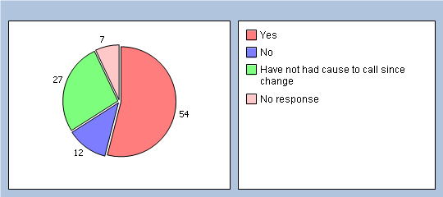

C. Arriving for your appointment

Q8. How easy do you find getting into the building at the Health Centre ?
Very easy 84%
Fairly easy 12%
Not very easy 0%
Not at all easy 0%
No response 4%
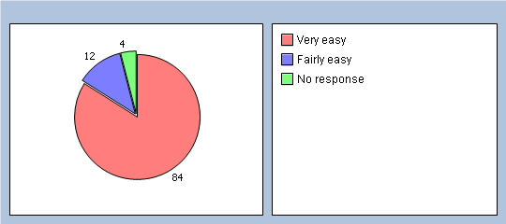

Q9. How did you find the cleanliness of the Medical Centre ?
Very clean 68%
Fairly clean 28%
Not very clean 1%
Not at all clean 0%
Don’t know 0%
No response 3%
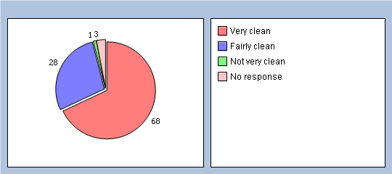

D. Seeing a Doctor

Q10, In the past 6 months have you tried to see a Doctor fairly quickly ? By fairly quickly we mean on the same day or in the next two weekdays that the GP Surgery or Health Centre was open.
Yes 63%
No 30%
Can't remember 2%
No response 5%
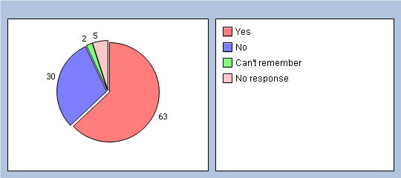

Q11. Think about the last time you tried to see a doctor fairly quickly. Were you able to see a doctor on the same day, or in the next two week days that the GP or Health Centre was open ?
Yes 73%
No 18%
Can't remember Yes 3%
No response 6%
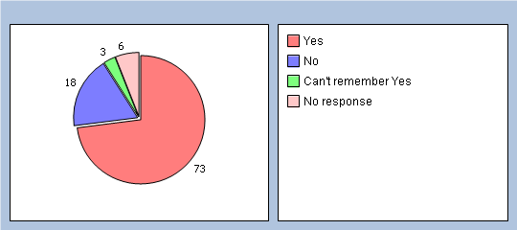

Q12. If you weren’t able to be seen during the next 2 weekdays that the Health Centre was open, why was that ? Please tick all that apply
There weren’t any appointments 21%
Times offered didn’t suit 2%
Appointment was with a Dr who I didn’t want to see 2%
A nurse was free but I wanted to see a Dr 4%
Another reason -Please enter reason in Q41 0%
Don't know 6%

Q13. In the past 6 months, have you tried to book ahead for an appointment with a Dr? By ‘booking ahead’ we mean booking an appointment more than two week days in advance.
Yes 63%
No 31%
Can't remember 0%
No response 6%
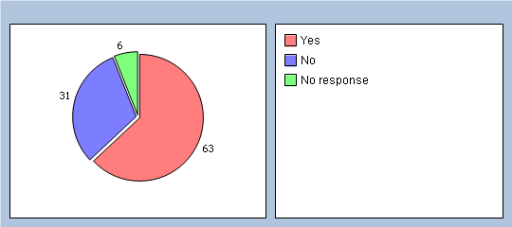

Q14. Last time you tried, were you able to get an appointment with a Dr more than 2 weekdays in advance ?
Yes 59%
No 22%
Can't remember 7%
No response 12%
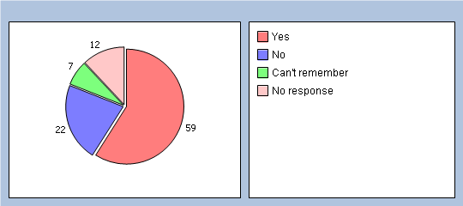

E. Seeing the Doctor you prefer

Q15. Is there a particular Dr you prefer to see at the Health Centre ?
Yes 68%
No 29%
No response 3%
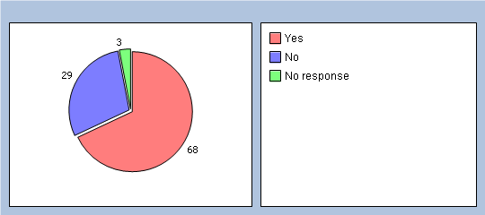

Q16. How often do you see the Dr you prefer ?
Always or most of the time 46%
A lot of the time 18%
Some of the time 11%
Never or almost never 2%
Not tried at this Health Centre 8%
No response 15%
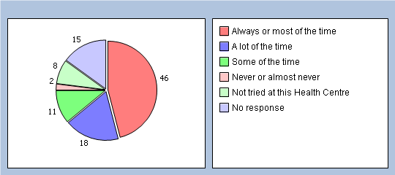

F. Opening Hours

Q17. How satisfied are you with the opening hours of the Health Centre ? Please note! We offer late evening appointments, up to 7.30pm on Wednesdays
Very 63%
Fairly 26%
Neither satisfied or dissatisfied 5%
Quite dissatisfied 1%
Very dissatisfied 0%
Don't know the opening hours 0%
No response 5%
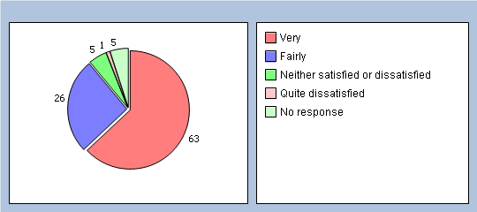

Q18. In a normal week can you access our services at the hours we are open?
With ease 86%
With some difficulty 10%
With great difficulty 0%
No response 4%
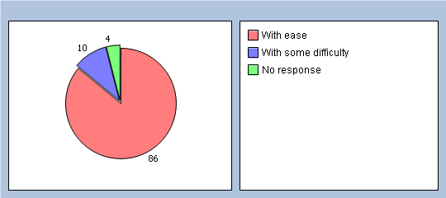

Q19. If accessing our services is difficult, when would you like us to open? Please enter the times when you wish to access our services.

G. Planning your care

Q20. Do you have any long-standing health problem, disability or infirmity? Please include anything that has troubled you over a period of time, or that is likely to affect you over a period of time ?
Yes - Go to Q21 55%
No - Go to Q29 34%
Don't Know/Can't say - Go to Q29 4%
No response 7%
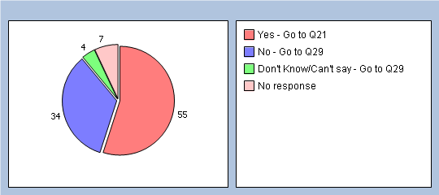

Q21. Have you had discussions in the past 12 months with a Doctor or Nurse, about how best to deal with your long-standing health problems?
Yes - Go to Q22 50%
No - Please go to Q35 and give reasons why, Then go to Q29 5%
No response 45%
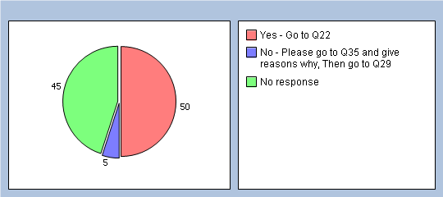
In these discussions ...............

Q22. Did the doctor or nurse take notice of your views about how to deal with your health problem?
Yes 50%
No 1%
Don’t Know 2%
N/A 0%
No response 47%
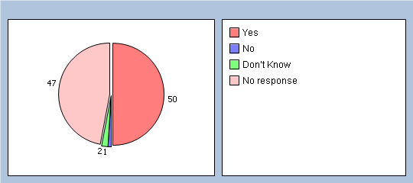

Q23. Did the doctor or nurse give you information about the things you might do to deal with your health problem ?
Yes 49%
No 3%
Don’t Know 0%
N/A 1%
No response 47%
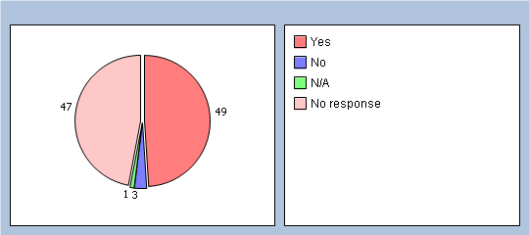

Q24. Did you and the doctor or nurse agree how best to manage your health problem ?
Yes 47%
No 1%
Don’t Know 2%
N/A 2%
No response 48%
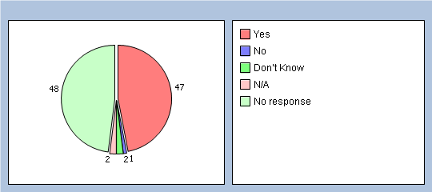

Q25. In these discussions, did the doctor or nurse give you a written document about managing your health problem ?
Yes 9%
No 39%
Don’t Know 1%
N/A 4%
No response 47%
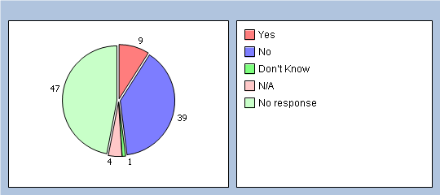

Q26. Would you have liked a written plan summarising your discussion with the doctor or nurse?
Yes 12%
No 31%
Don’t Know 4%
N/A 5%
No response 48%
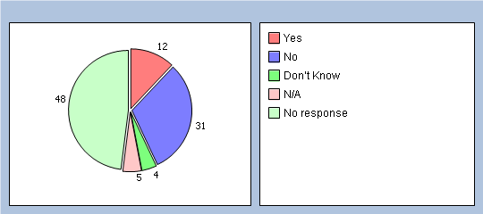

Q27. Did you think that having these discussions with your doctor or nurse has helped improve how you manage your health problems?
Yes 29%
To some extent 19%
No 2%
Don't know/Can't remember 2%
No response 48%
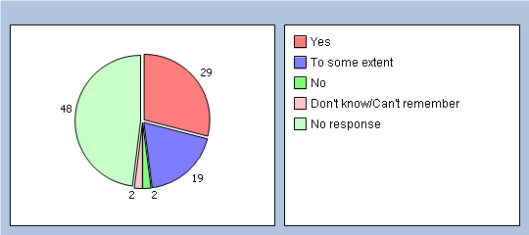

Q28. In the past 6 months, have you had enough support from local services or organisations to help you manage your long-term health condition(s)? Please think about all services and organisations, not just health services.
Yes 24%
To some extent 9%
No 6%
Don't know/Can't remember 1%
I have not needed such support 12%
No response 48%
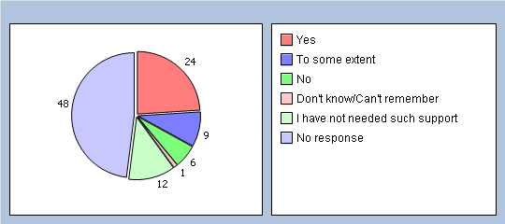

H. To help us analyse your answers please tell us a few things about yourself:

Q29. Are you?
Male 24%
Female 70%
No response 6%
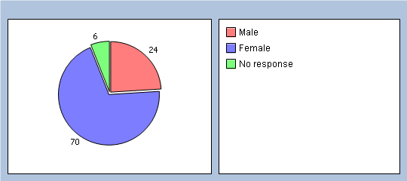

Q30. What age are you?
Under 18 2%
18 – 24 5%
25 – 34 8%
35 – 44 14%
45 – 54 17%
55 – 64 11%
65 – 74 23%
75 – 84 8%
85 and over 2%
No response 10%
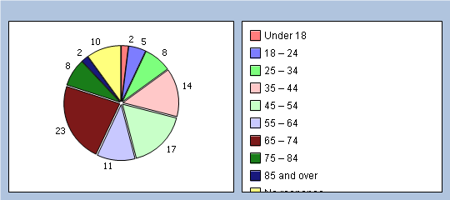

Q31. Which best describes what you are doing at present ? If more than one of these applies to you please tick the main one ONLY
Full-time paid work (30 hours or more per week) 23%
Part-time paid work (under 30 hours per week) 18%
Full time education (school, college, university) 1%
Unemployed 0%
Permanently sick or disabled 3%
Fully retired from work 31%
Looking after the home 13%
Doing something else 4%
No response 7%
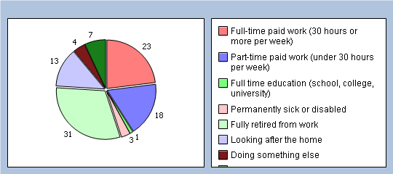

Q32. What is your ethnic group?
White 94%
Black or Black British 0%
Asian or Asian British 0%
Mixed 1%
Chinese 0%
Other ethnic group 0%
No response 5%
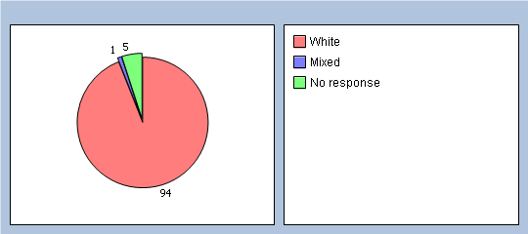

I. Your Overall Satisfaction

Q33. In general, how satisfied are you with the care you get at the William Fisher Medical Centre?
Very 79%
Fairly 17%
Neither satisfied or dissatisfied 0%
Quite dissatisfied 0%
Very dissatisfied 0%
No response 4%
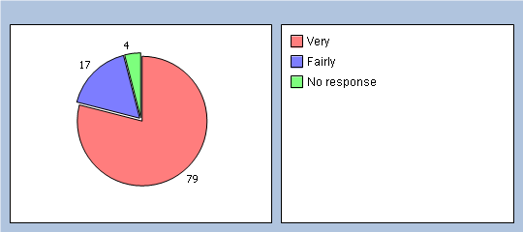

Q34.Would you recommend the William Fisher Medical Centre to someone who has just moved to your local area?
Yes 93%
Might 2%
Not Sure 0%
Probably not 0%
Definitely not 0%
Don’t know 0%
No response 5%
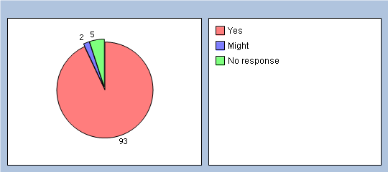

Q35. Finally please add any other comments you would like to make about the William Fisher Medical Centre

Many thanks for your time in answering the questions on this survey.

