William Fisher Medical Centre Patient Questionnaire March 2012

Number of Responses: 165
We hope you will be willing to complete this short survey to help us have a better understanding of our patients and their health needs. We are targeting our patients who live outside of Southminster or Burnham and may have difficulties in accessing our services and in getting to hospital. Our Patient Participation Group will study the results of the survey and their findings and any actions they wish to undertake will be published on our new practice website as well as displayed in the surgery. If you prefer, you can complete the survey on line, just go to the link from the home page.The website http://www.williamfishermedicalcentre.nhs.uk/ also contains useful patient information and an easy way of emailing your repeat prescription requests.
Please answer all the questions and add any comments you like. We particularly find these useful if you have given us a low rating as this helps us identify a problem. Please post it back to us in the s.a.e.provided by 5 March 2012 and thank you for your time.

Appointments
Q1 If you need to see a GP urgently, can you normally get seen on the same day?
Yes 69%
No 10%
Don’t know / never needed to 19%
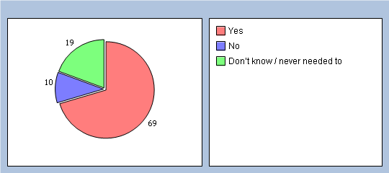
Q2 How easy is it to book ahead in your practice?
Very easy 41%
Fairly easy 37%
Not very easy 12%
Not at all easy 1%
Don’t know 2%
Haven’t tried 2%
No response 5%
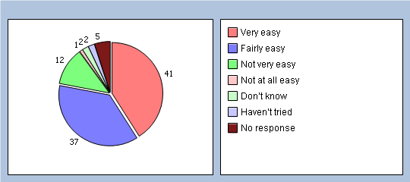

Thinking of times when you want to see a particular doctor:
Q3 How quickly do you usually get seen?
Same day or next day 12%
2-4 days 22%
5 days or more 47%
I don’t usually need to be seen quickly 4%
Don’t know, never tried 10%
No response 5%
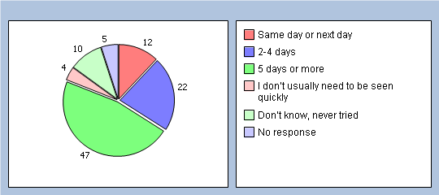

Q4 How do you rate this?
Excellent 10%
Very good 22%
Good 15%
Fair 23%
Poor 13%
Very poor 3%
Does not apply 9%
No response 5%
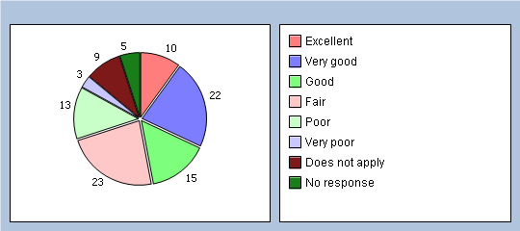

Thinking of times when you are willing to see any doctor:

Q5 How quickly do you usually get seen?
Same day or next day 47%
2-4 days 29%
5 days or more 7%
I don’t usually need to be seen quickly 6%
Don’t know, never tried 9%
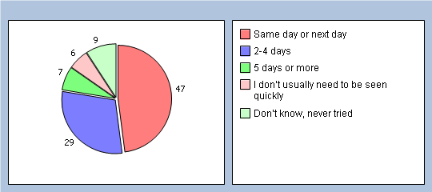

Q6 How do you rate this?
Excellent 21%
Very good 26%
Good 16%
Fair 14%
Poor 4%
Very poor 0%
Does not apply 11%
No response 8%
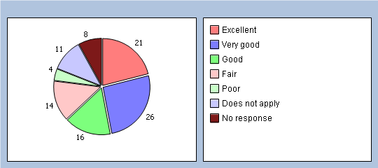

About opening times

Q7 Is your GP practice currently open at times that are convenient to you?
Yes - Go to Q9 81%
No 13%
Don’t know 3%
No response 3%
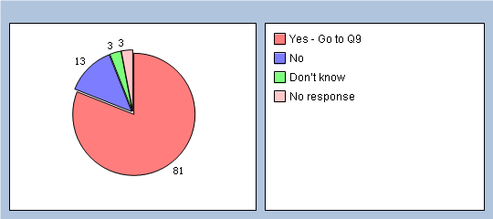

Q8 Which of the following additional opening hours would make it easier for you to see or speak to someone? Please tick all boxes that apply.
Before 8am 11%
At lunchtime 9%
After 6.30pm 14%
On a Saturday 19%
On a Sunday 5%
None of these 1%

This is about how you get to your appointments
Q9 How easy is it for you to get to the surgery
Very easy 44%
Quite easy 47%
Quite difficult 7%
Very difficult or impossible 0%
No response 2%
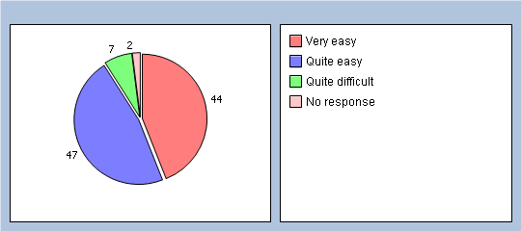

Q10 How do you usually get to the surgery
Drive myself 81%
Driven by someone else 12%
Public transport 2%
Taxi 1%
Walk or cycle 0%
Other 0%
No response 4%
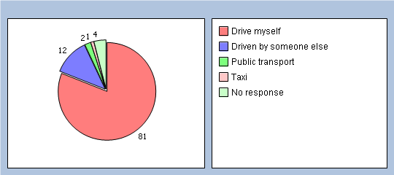

Q11 How easy is it for you to get to Broomfield Hospital
Very easy 16%
Quite easy 50%
Quite difficult 26%
Very difficult or impossible 4%
No response 4%
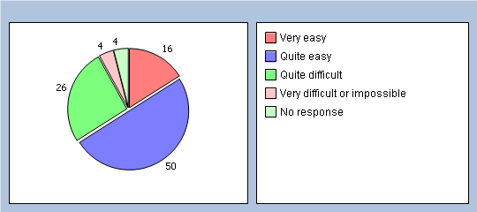

Q12 How would you get to Broomfield Hospital for a non emergency appointment
Drive myself 69%
Driven by someone else 22%
Ambulance 1%
Public transport 3%
Taxi 1%
Other 0%
No response 4%
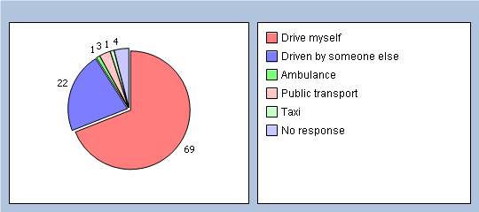

It will help us to understand your answers if you could tell us a little about yourself

Q13 Are you?
Male 26%
Female 72%
No response 2%
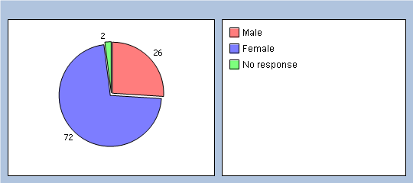

Q14 How old are you?
Under 16 0%
16 to 44 24%
45 to 64 30%
65 to 74 31%
75 or over 10%
No response 5%
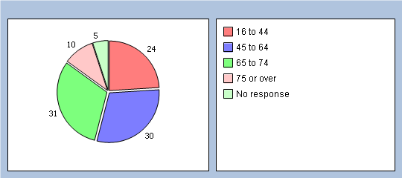

Q15 Do you have a long-standing health condition?
Yes 49%
No 42%
Don’t know / can’t say 5%
No response 4%
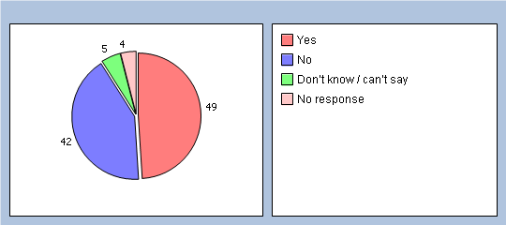

Q16 What is your ethnic group?
White 94%
Black or Black British 0%
Asian or Asian British 0%
Mixed 0%
Chinese 0%
Other ethnic group 1%
No response 5%
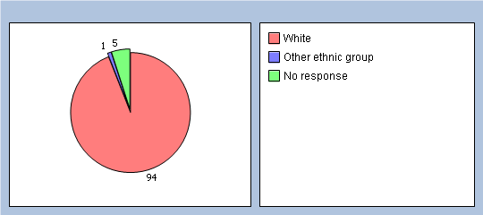

Q17 Which of the following best describes you?
Employed (full or part time, including self-employed) 38%
Unemployed / looking for work 0%
At school or in full time education 0%
Unable to work due to long term sickness 1%
Looking after your home/family 10%
Retired from paid work 43%
Other 1%
No response 7%
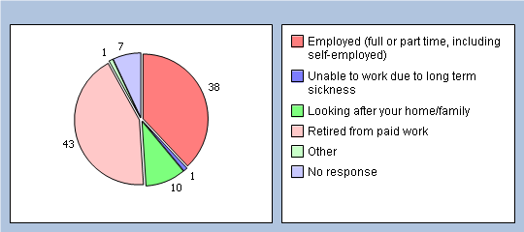

Finally, please add any other comments you would like to make about your GP

