William Fisher Medical Centre Patient Questionnaire March 2013

Dear Patient,
We hope you will be willing to complete this short survey to help us have a better understanding of our patients and their health needs.
Our Practice Manager and Patient Participation Group will analyse the results and prepare an action plan, to address patient concerns where it is possible to do so.
To make the results more accessible, the survey results and comments, together with the action plan will be published on the practice website as well as being displayed in the surgery.
Please consider joining our Virtual Patient Participation Group. By becoming a member we will communicate with you by email, requesting that you visit our website and complete any future surveys we may undertake from time to time. We will keep our surveys succinct so it shouldn’t take too much of your time.
If you are happy for us to contact you occasionally by email, please click the ' Join Our Patient Group' link on our website 'Home' page to open the sign-up form and complete all the fields.

2013 Patient Survey
Please answer all of the questions and click 'Send Survey' when you are done.
A. Appointments at your Health Centre
Q1. When did you last see a Doctor at the Health Centre?
In the past 3 months 78%
Between 3 and 6 months ago 11%
More than 6 months ago 8%
I have never been seen at my present Health Centre 0%
No response 3%
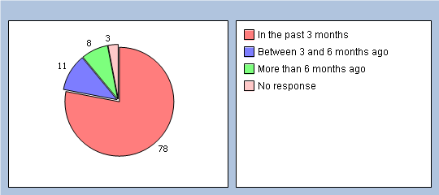

Q2. If you haven't seen a Doctor in the past 6 months, why is that ? Please tick all that apply
I haven't needed to see a Doctor 12%
I couldn't be seen at a convenient time 0%
I couldn't get to my appointment easily 0%
Another reason 2%

B.Getting through on the phone

Q3. In the past 6 months how easy have you found getting through on the phone ?
Haven't tried 6%
Very easy 48%
Fairly easy 30%
Not very easy 10%
Not at all easy 1%
Dont know 1%
No response 4%
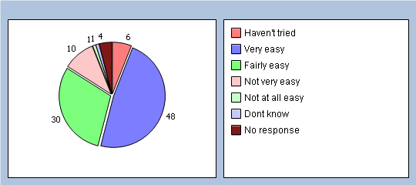

Q4. In the past 6 months how easy have you found getting to speak to a Doctor on the phone ?
Haven't tried 62%
Very easy 5%
Fairly easy 8%
Not very easy 1%
Not at all easy 3%
Dont know 11%
No response 10%
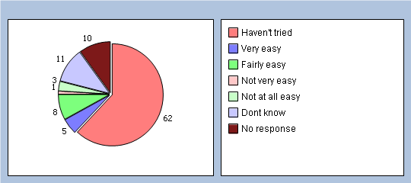

Q5. In the past 6 months how easy have you found getting to speak to a Nurse on the phone ?
Haven't tried 56%
Very easy 11%
Fairly easy 10%
Not very easy 1%
Not at all easy 2%
Dont know 10%
No response 10%
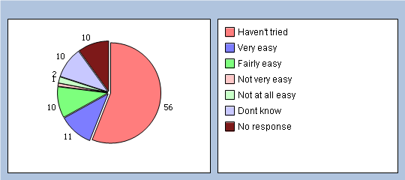

Q6. In the past 6 months how easy have you found obtaining test results on the phone ?
Haven't tried 53%
Very easy 16%
Fairly easy 9%
Not very easy 3%
Not at all easy 3%
Dont know 8%
No response 8%
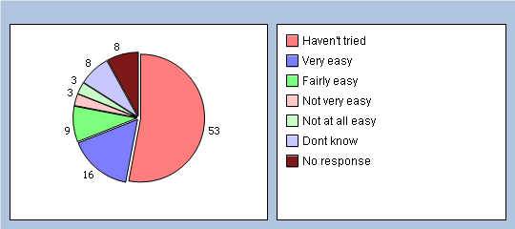

Q7. At present all calls are answered by our receptionists, which inevitably results in delays at busy times. Would it be helpful if we had a system with a recorded message indicating where you are in the queue, if a receptionist cannot answer straight away ?
Yes 67%
No 27%
No response 6%
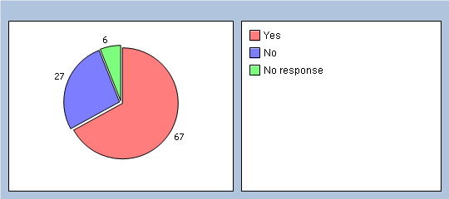

C. Arriving for your appointment

Q8. How easy do you find getting into the building at the Health Centre ?
Very easy 90%
Fairly easy 7%
Not very easy 1%
Not at all easy 0%
No response 2%
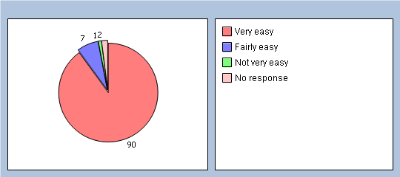

Q9. How did you find the cleanliness of the Medical Centre ?
Very clean 72%
Fairly clean 25%
Not very clean 1%
Not at all clean 0%
Dont know 0%
No response 2%
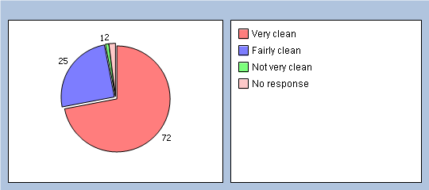

D. Seeing a Doctor

Q10, In the past 6 months have you tried to see a Doctor fairly quickly ? By fairly quickly we mean on the same day or in the next two weekdays that the GP Surgery or Health Centre was open.
Yes 66%
No 26%
Can't remember 3%
No response 5%
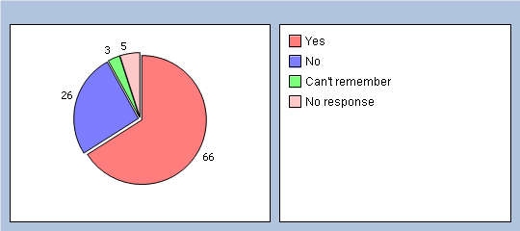

Q11. Think about the last time you tried to see a doctor fairly quickly. Were you able to see a doctor on the same day, or in the next two week days that the GP or Health Centre was open ?
Yes 74%
No 15%
Can't remember 5%
No response 6%
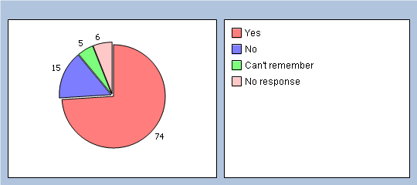

Q12. If you weren’t able to be seen during the next 2 weekdays that the Health Centre was open,why was that ? Please tick all that apply
There weren’t any appointments 18%
Times offered didn’t suit 2%
Appointment was with a Dr who I didn’t want to see 3%
A nurse was free but I wanted to see a Dr 6%
Another reason -Please enter reason in Q41 3%
Don't know 2%

Q13. In the past 6 months, have you tried to book ahead for an appointment with a Dr? By ‘booking ahead’ we mean booking an appointment more than two week days in advance.
Yes 64%
No 26%
Can't remember 3%
No response 7%
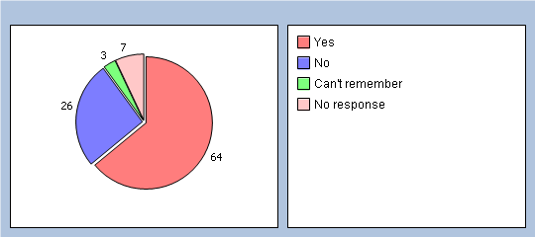

Q14. Last time you tried, were you able to get an appointment with a Dr more than 2 weekdays in advance ?
Yes 58%
No 20%
Can't remember 5%
No response 17%
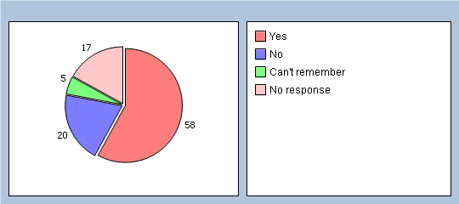

E.Seeing the Doctor you prefer

Q15. Is there a particular Dr you prefer to see at the Health Centre ?
Yes 70%
No 25%
No response 5%
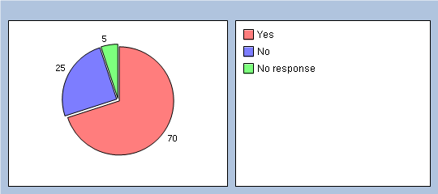

Q16. How often do you see the Dr you prefer ?
Always or most of the time 52%
A lot of the time 16%
Some of the time 13%
Never or almost never 0%
Not tried at this Health Centre 6%
No response 13%
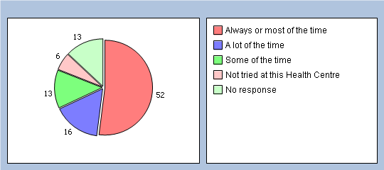

F. Opening Hours

Q17. How satisfied are you with the opening hours of the Health Centre ? Please note! We offer late evening appointments, up to 7.30pm on thursdays
Very 67%
Fairly 27%
Neither satisfied or disatisfied 1%
Quite dissatisfied 0%
Very dissatisfied 1%
Don't know the opening hours 0%
No response 4%
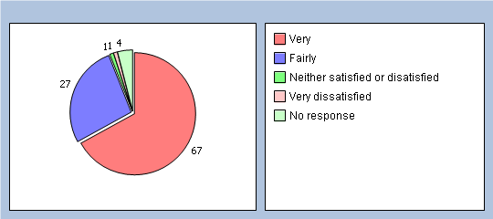
Q18. In a normal week can you access our services at the hours we are open?
With ease 88%
With some difficulty 8%
With great difficulty 0%
No response 4%
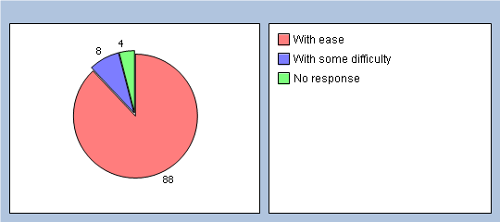

Q19. If accessing our services is difficult, when would you like us to open? Please enter the times when you wish to access our services.

G. Planning your care

Q20. Do you have any long-standing health problem, disability or infirmity? Please include anything that has troubled you over a period of time, or that is likely to affect you over a period of time ?
Yes - Go to Q21 64%
No - Go to Q29 31%
Don't Know/Can't say - Go to Q29 0%
No response 5%
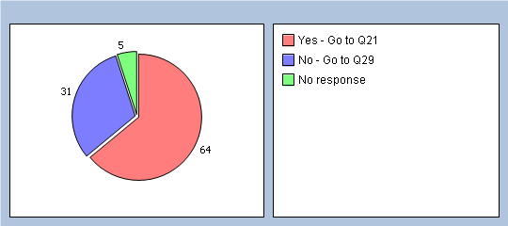
Q21. Have you had discussions in the past 12 months with a Doctor or Nurse, about how best to deal with your long-standing health problems?
Yes - Go to Q22 63%
No - Please go to Q41 and give reasons why, Then continue to Q29 7%
No response 30%
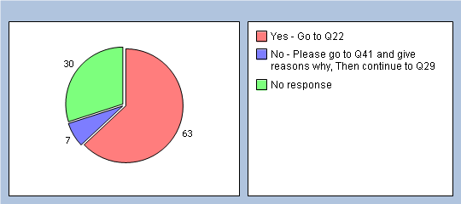

In these discussions ...............

Q22. Did the doctor or nurse take notice of your views about how to deal with your health problem ?
Yes 58%
No 1%
Dont Know 1%
N/A 1%
No response 39%
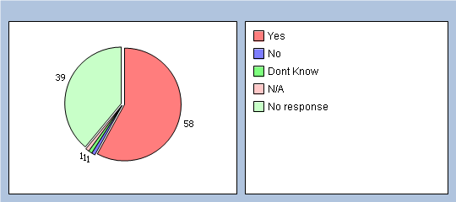

Q23. Did the doctor or nurse give you information about the things you might do to deal with your health problem ?
Yes 53%
No 6%
Dont Know 1%
N/A 1%
No response 39%
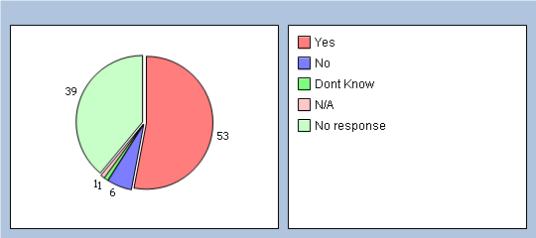

Q24. Did you and the doctor or nurse agree how best to manage your health problem ?
Yes 51%
No 5%
Dont Know 1%
N/A 3%
No response 40%
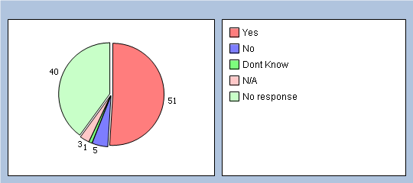

Q25. In these discussions, did the doctor or nurse give you a written document about managing your health problem ?
Yes 8%
No 44%
Dont Know 1%
N/A 7%
No response 40%
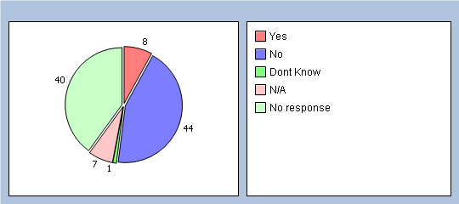

Q26. Would you have liked a written plan summarising your discussion with the doctor or nurse?
Yes 16%
No 31%
Dont Know 6%
N/A 6%
No response 41%
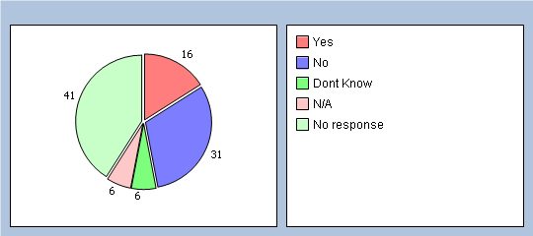

Q27. Did you think that having these discussions with your doctor or nurse has helped improve how you manage your health problems?
Yes 35%
To some extent 17%
No 6%
Don't know/Can't remember 0%
No response 42%
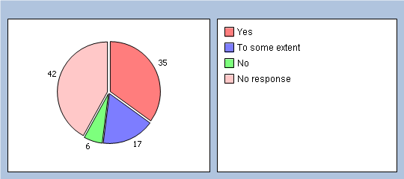

Q28. In the past 6 months, have you had enough support from local services or organisations to help you manage your long-term health condition(s)? P lease think about all services and organisations, not just health services.
Yes 26%
To some extent 11%
No 8%
Don't know/Can't remember 1%
I have not needed such support 17%
No response 37%
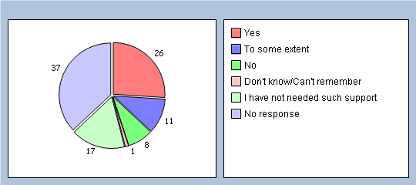

H Emergency Ambulance Service

Q29. Have you had cause to call for an Ambulance within the last 6 months?
Yes - Go to Q30 12%
No - Go to Q35 77%
No response 11%
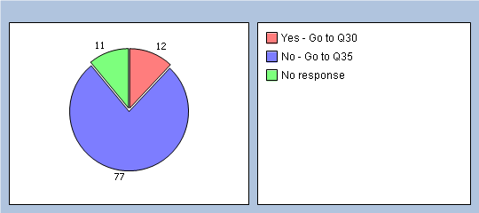

Q30. Did you first receive a visit from a Paramedic ?
Yes - Go to Q31 8%
No - Go to Q34 11%
No response 81%
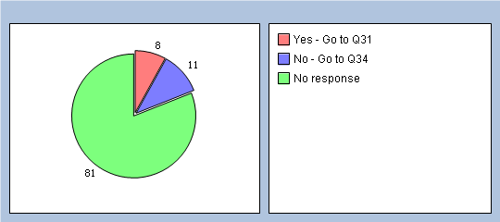

Q31. Please indicate how long you had to wait before the Paramedic arrived.
within 10 min. 1%
Longer than 10 min but less than 20 min 2%
Longer than 20 min but less than 30 min 3%
Longer than 30 min but less than 40 min 1%
Longer than 40 min but less than 50 min 0%
Longer than 50 min but less than 60 min 1%
Longer than 1 hour 1%
No response 91%
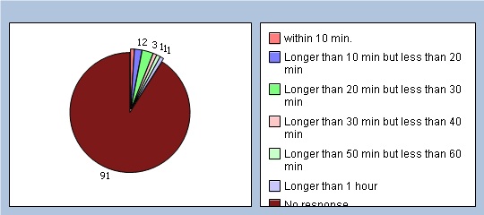

Q32. Was the Paramedic able to deal with your concern without the need to send you to hospital ?
Yes 3%
No 6%
No response 91%
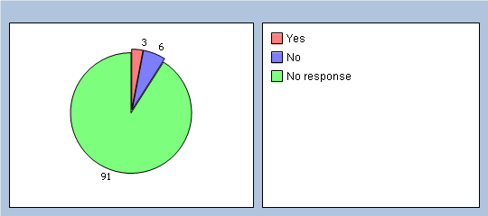

Q33. Were you happy with this ?
Yes 5%
No 2%
No response 93%
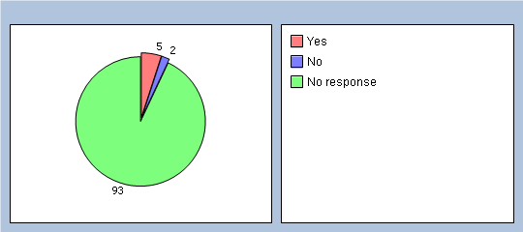

Q34. If the Ambulance arrived first or the Paramedic called for the Ambulance, how long did it take for it to arrive ?
within 10 min. 0%
Longer than 10 min but less than 20 min 1%
Longer than 20 min but less than 30 min 3%
Longer than 30 min but less than 40 min 0%
Longer than 40 min but less than 50 min 0%
Longer than 50 min but less than 60 min 0%
Longer than 1 hour 2%
No response 94%
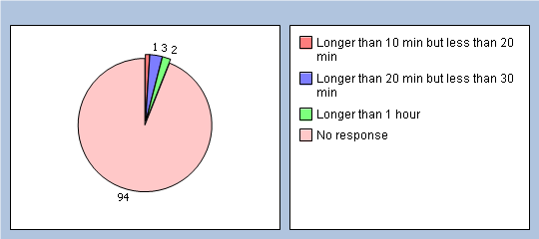

I. To help us analyse your answers please tell us a few things about yourself:

Q35. Are you ?
Male 32%
Female 66%
No response 2%
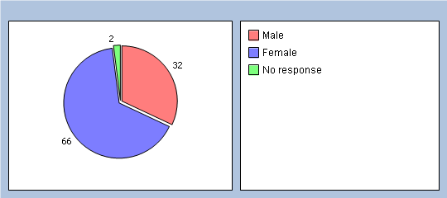

Q36. What age are you?
Under 18 0%
18 - 24 0%
25 - 34 1%
35 - 44 9%
45 - 54 13%
55 - 64 19%
65 - 74 34%
75 - 84 15%
85 and over 4%
No response 5%
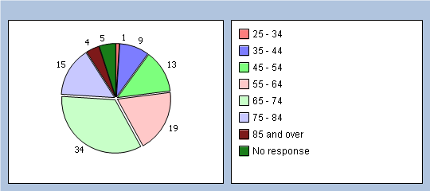

Q37. Which best describes what you are doing at present ? If more than one of these applies to you please tick the main one ONLY
Full-time paid work (30 hours or more per week) 16%
Part-time paid work (under 30 hours per week) 14%
Full time education (school, college, university) 0%
Unemployed 2%
Permanently sick or disabled 7%
Fully retired from work 49%
Looking after the home 5%
Doing something else 2%
No response 5%
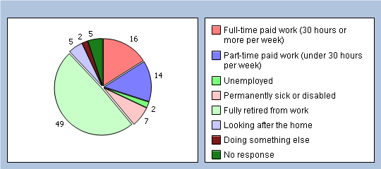

Q38. What is your ethnic group ?
White 97%
Black or Black British 0%
Asian or Asian British 0%
Mixed 0%
Chinese 0%
Other ethnic group 0%
No response 3%
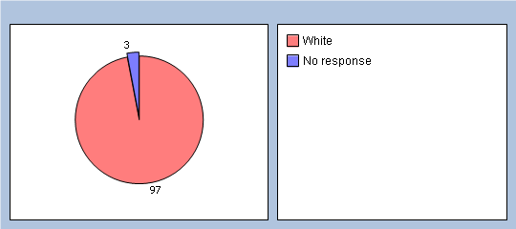

J. Your Overall Satisfaction

Q39. In general, how satisfied are you with the care you get at the William Fisher Medical Centre ?
Very 78%
Fairly 16%
Neither satisfied or disatisfied 1%
Quite dissatisfied 2%
Very dissatisfied 0%
No response 3%
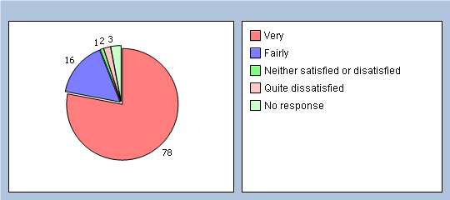

Q40.Would you recommend the William Fisher Medical Centre to someone who has just moved to your local area ?
Yes 88%
Might 5%
Not Sure 2%
Probably not 1%
Definitely not 0%
Dont know 0%
No response 4%
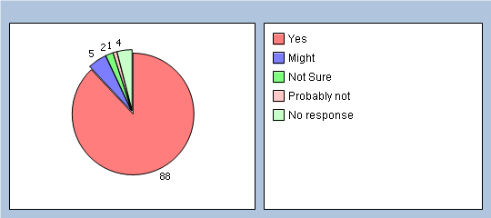

Q41. Finally please add any other comments you would like to make about the William Fisher Medical Centre

Many thanks for your time in answering the questions on this survey.

